Regular Expression

Lab 12. Regular Expression 1
12.1. Open workspace and Create Folder 2
12.2. Product Information Request 3
12.3. Date Validation 5
12.4. Exercise 6

Open workspace and Create Folder

Open Zend Studio 7.0
- Select Start → All Programs → Zend Studio – 7.0.0 → Zend Studio – 7.0.0
- Choose OK to confirm the workspace.
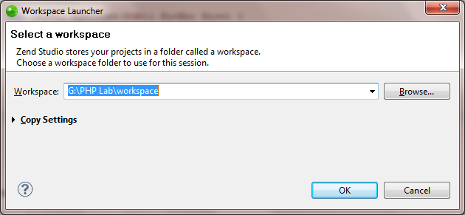
- Close all the opening file in the PHP Editor view by right click to a file and choose Close All.
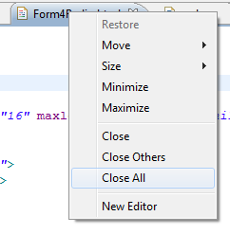

Right click on LapProject, choose New Folder. Enter Lab7 as folder name.

Product Information Request

ProductRequest.html
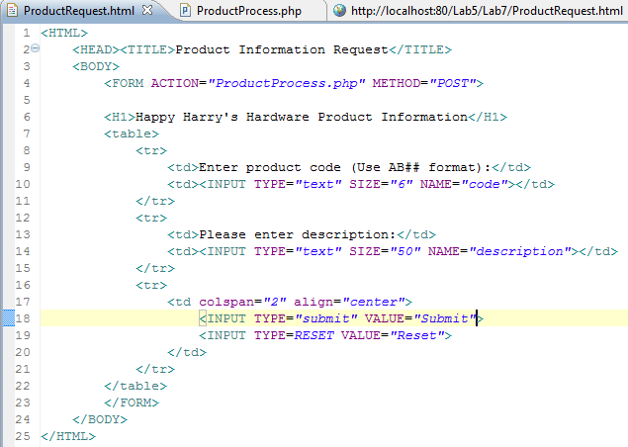

ProductProcess.php
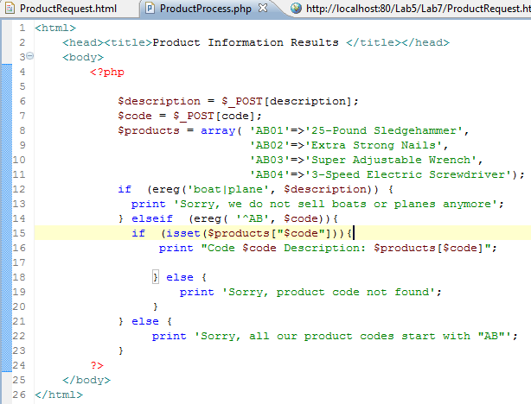

Run
1)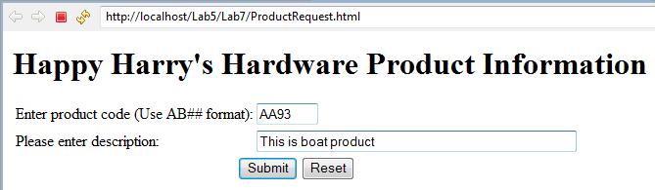

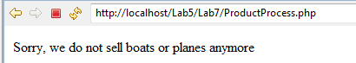
2)
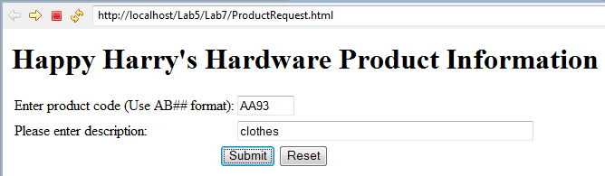

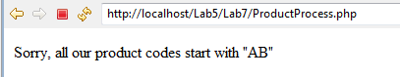
3)
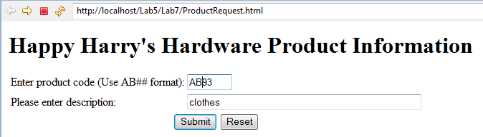
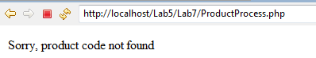
4)
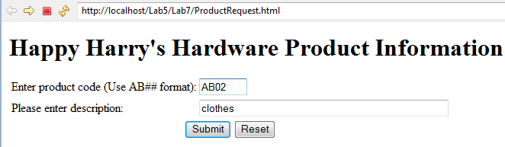

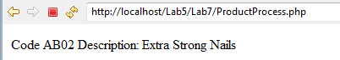

Date Validation

CheckDate.html
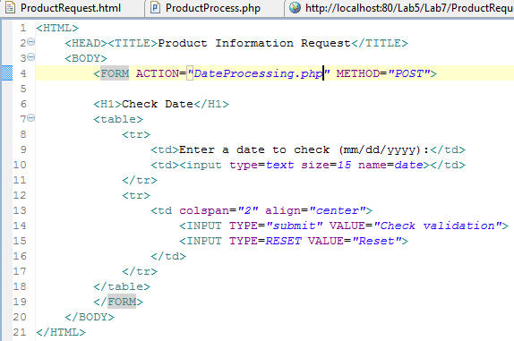

DateProcessing.php
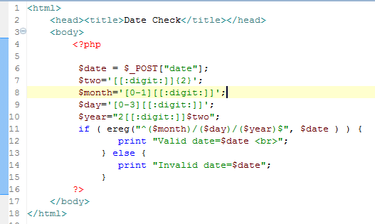

Run
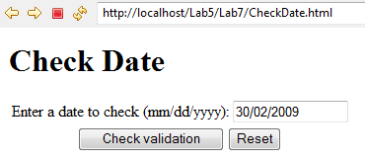

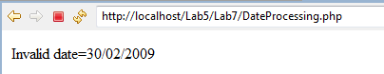

Modify 12.3 to fully check a valid date

Exercise
            - Compare the preg_match() function with ereg() funtion; preg_replace() function with ereg_replace() function.
            - Write a web page to input and validate the followings using regular expressions:
- Email address
- URL address
- Phone number

